FAAA CONTINUING PROFESSIONAL DEVELOPMENT PLAN TEMPLATE

CONTINUING PROFESSIONAL DEVELOPMENT PLAN
A Continuing Professional Development Plan (CPD plan) sets out the identified learning activities that support the development of technical competencies, professional skills and personal attributes required for effective performance and participation within the financial services industry.

The CPD plan sits at the centre of the CPD areas model. It is a legislative requirement that each adviser has a CPD plan prepared with, and approved by, their licensee at the beginning of each CPD year.

The CPD plan should be comprehensive, and development opportunities considered from each CPD area in order to meet the minimum CPD hours requirement.

CPD Plan process
Figure 1, outlines a five step CPD plan process. After reviewing the process, complete each step to help you identify learning activity opportunities across each CPD area, record your CPD learning activity, reflect on your learning experiences to identify new opportunities and determine your CPD objectives. Use the reflection questions, in each step, to help you identify CPD opportunities across each CPD area.

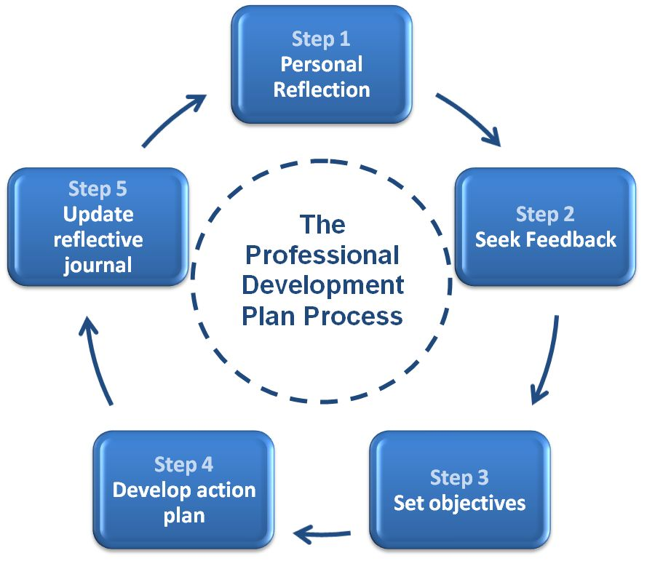
Figure 1. Five step CPD plan process

Step 1: Personal reflection

Technical competence: The activity is designed to enhance participants’ technical proficiency and ability to develop and provide advice strategies that are appropriate to the objectives, financial situations, and needs of different classes of retail clients.
Reflection questions  Am I up-to-date with the impacts of the federal budget, legislation, economic developments and financial markets?  Have I met the regulators’ requirements to maintain, update and develop my knowledge and skills in the areas I am authorised to deal in or give advice on?  Do I have the specialist knowledge and cognitive skills of decision making to develop the strategies and financial solutions that best meet the needs of my clients?  What other financial planning skills or technical knowledge do I need, to effectively perform my role? For example SMSFs, estate planning, aged care or negotiation, listening, leadership skills  Do I have the appropriate practice management skills, to effectively manage my financial planning practice? | Notes
CPD opportunities

Client care and practice: The activity is designed to enhance participants’ ability to act as a client-centric practitioner in advising retail clients.
Reflection questions  What feedback do I get from my clients?  Do my clients consider me ‘referable’? How do I know?  Do I seek feedback from my colleagues and clients? If so, what does it tell me? Do I need to make improvements?  How do I ensure the advice I give is client-centric and ethically based?  How do I demonstrate to clients the basis for my advice?  Do I adequately seek new advice opportunities and solutions for clients?  Do I adequately identify potential conflicts and risks?  Do my communication and presentation skills need improving?  Have I kept up-to-date with current industry and economic issues that may impact the plans of my existing clients?  How do I apply my technical capabilities to unique client situations? | Notes
CPD opportunities

Regulatory compliance and consumer protection: The activity is designed to enhance participants’ understanding of applicable legal obligations and how to comply with them.
Reflection questions  Am I up-to-date with my compliance obligations?  Do I need to up-skill in any areas following my last compliance audit?  Is there anything I need to improve on in the area of complaints?  Do I have an understanding of the current regulations and legislation relevant to the Financial Planning profession?  Do I know where to go to learn about my legal obligations?  Am I prepared, if I am asked to witness a statutory declaration?  Am I fully aware of my disclosure obligations, in relation to an FSG, SoA and PDS? | Notes
CPD opportunities

Professionalism and ethics: The activity is designed to enhance participants’ capacity to act as an ethical professional.
Reflection questions  Am I up to date with the FAAA Professional Code and practice standards?  Do I adhere to the Financial Planners and Advisers Code of Ethics?  How do (or did) I deal with managing conflicts ethically?  What are my personal ethics and values? Do I know how they impact my clients, for example, do I inspire trust and confidence?  How do I reflect my ethics in my client value proposition?  Do I conduct open and honest conversations and interviews with my clients? | Notes
CPD opportunities

General: This activity is designed to maintain and extend participants’ professional capabilities, knowledge, and skills, including keeping up to date with regulatory, technical and other relevant developments, but is not in another CPD area.
Reflection questions  Do I understand my professional strengths and weaknesses?  What differentiates me from others?  Are there any opportunities to improve my job satisfaction?  Have I developed an effective network and do I know how to use it well?  Do I negotiate workable solutions?  Am I managing the pressures of work as well as I can?  What leadership qualities do I have, and what skills need further refinement?  Do I know if I am an effective leader?  Who inspires me? What is it about them that I would like to learn? | Notes
CPD opportunities

Step 2: Seek feedback

Review your responses to Step 1 with your supervisor, mentor, colleagues and staff. They may assist you in gaining further insight and identifying new CPD opportunities across each CPD area. List any newly identified CPD opportunities:

1. | 4.
2. | 5.
3. | 6.

Step 3: Set objectives

Your objectives describe what you want to achieve and Key Performance Indicators, are a measurable value that demonstrates how effectively you are achieving your objectives. Use the insights gained from Step 1 and Step 2 to identify three objectives that you would most like to achieve over the next CPD year.

Objectives | Key Performance Indicators
1. | 1.
2. | 2.
3. | 3.

Step 4: Develop an Action plan

Name: Licensee:
Start date: End date:

CPD learning activity | CPD area | CPD hours | Due date | Delivery format | Provider name

Step 5: Keep a Reflective journal

A Reflective journal is used to record learning from real life situations and apply formal learning into practice. It encourages you to observe your experiences, analyse what happened and think about ways to use these experiences to improve and develop professionally. This can assist in improving your client-centric practices.

Reflection questions | Your response
What was the situation?
What happened in this situation?
How did you go about it?
Why did you go about it that way?
What was the outcome?
What did you do well?
What could you have done better?
What would you do differently next time?

